Name:
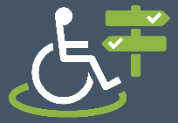
Accessible Bath
Street Name and Number  e.g. 63 Milsom Street | Premises Name  e.g. Dentist, Waitrose, Pizza Express, Bus Stop E | Wheelchair Access  Green  Orange  Red  Unknown | Toilet Access  Green  Orange  Red  Unknown | Comments to go on to Wheelmap  e.g. A single step up to the front door that is about 8 inches high. | Other Notes  e.g. Shop name needs updating on Wheelmap.

